

Course: Mathematics Methods Year: 11

Student Name: Teacher Name:

Date: 14/06/21 – 21/06/21

Task Type: Investigation

Time Allowed: 50 minutes (subject to change)

Number of Questions: 12 (subject to change)

Materials Required: Calculator with CAS ability (ClassPad) and this take-home section

Standard Items: Pens (blue/black preferred), pencils (including coloured), sharpener, correction fluid/tape, eraser, ruler and highlighters

Special Items: Drawing instruments, templates, take-home section and up to three calculators approved for use in the WACE examinations

Marks Available: 50 marks (subject to change)

Task Weighting: 10 % (Year)

Formula Sheet Provided: Yes

Note: All questions worth more than 2 marks require working to obtain full marks.
INVESTIGATION 2: DIFFERENTIAL CALCULUS
Optimising Motion

In mathematics and science, you have analysed motion by considering displacement, velocity and acceleration. Velocity is the rate of change of displacement or the first derivative of displacement with respect to time, while acceleration is the rate of change of velocity or the second derivative of displacement.

As you know, instantaneous changes in displacement are impossible. As the time interval to change displacement approaches zero, the velocity required approaches infinity, and when the time interval is zero, the velocity cannot be defined. Similarly, instantaneous changes in velocity are impossible, requiring an acceleration that cannot be defined.

Below is a scenario of motion that is commonly analysed in school. Consider the scenario and complete the questions.

An elevator moves upwards with velocity $v m/s$ over time $t seconds$ as shown below:
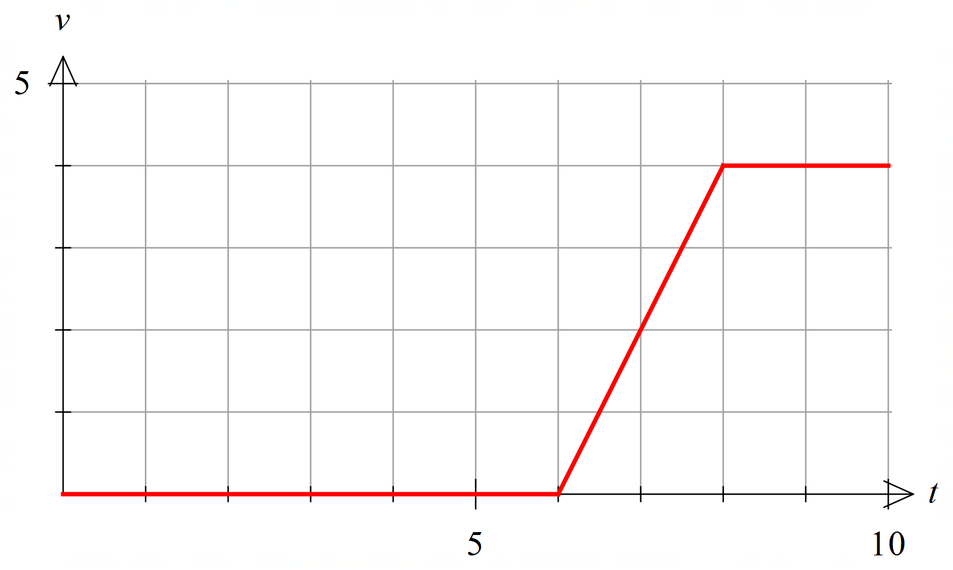

Describe the motion of the elevator and determine the piecewise function of its velocity over the interval shown.

$∴v\left(t\right)=\left\{\begin{aligned} 0 0≤t<6 \\ \begin{aligned} __________ 6≤t<8 \\ 4 8≤t≤10\end{aligned}\end{aligned}\right.$

Using differential calculus, determine the piecewise function of the elevator’s acceleration.
Note: The function does not exist at each point of discontinuity in the acceleration, because the gradient of the velocity graph cannot be found.

Hence, plot the acceleration $a m/s^{2}$ over time $t seconds$ in the graph below.
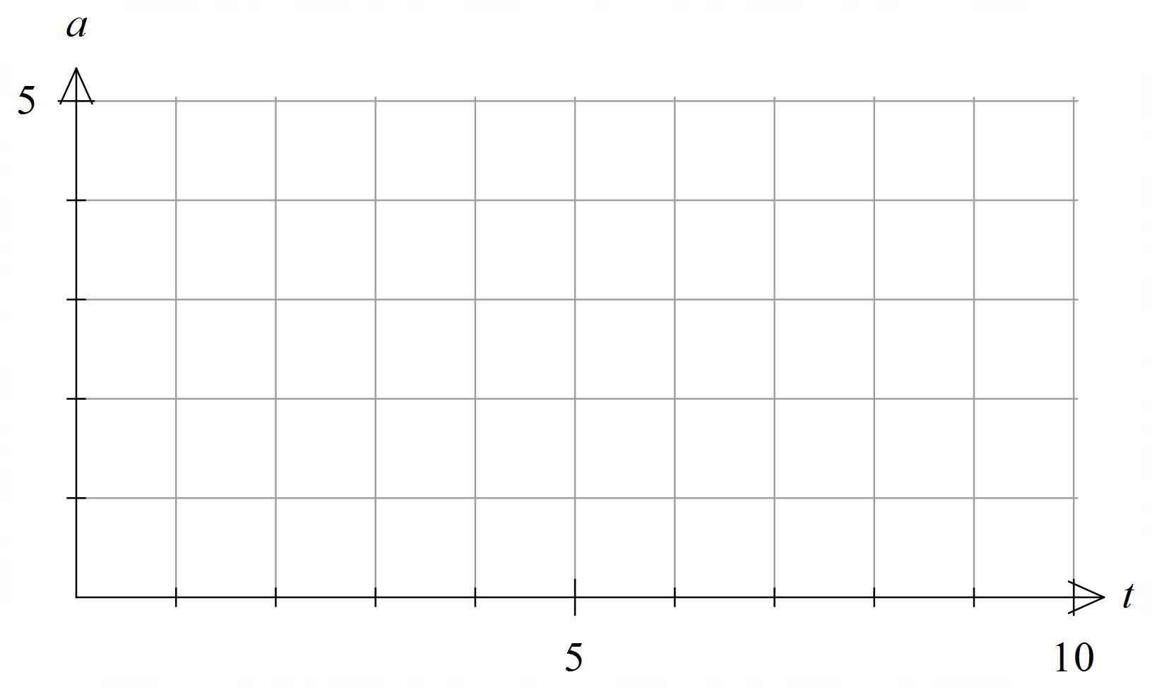

As you should see above, the acceleration changes instantly between $0 m/s^{2}$ and $2 m/s^{2}$. This cannot happen in the real world, yet most examples of piecewise motion that are considered in school involve such changes in acceleration (albeit for simplicity).

The rate of change of acceleration or the third derivative of displacement is called jerk. While in theory the acceleration above changes instantly, this translates to reality as a change in acceleration over a very short period, producing a very high jerk.

Jerk is an important consideration in design and applications such as transportation and machinery. As you should know:
- We do not feel velocity: When you are in a car travelling at a constant velocity, you do not feel how fast you are going.
- We do feel acceleration: When you are in a car accelerating at a constant rate, you feel a constant force from your car seat.

We also feel jerk – how quickly our acceleration changes. Suppose you are driving a car and you decide to test it by repeatedly braking hard:
- If you press and release the brakes suddenly each time, the jerk is high. You feel the force on you appear and disappear, but it is sudden, and the ride feels ‘jerky’ and unpleasant. This can also be damaging to your car.
- If you ease on and off the brakes each time, the jerk is low. You feel the force on you increasing (to the same maximum) and decreasing, but it is smooth and steady.

High accelerations and jerks are both generally undesirable.
- High accelerations (forces) can injure passengers or overload machinery.
- High jerk can result in discomfort to passengers or damaging vibration in machinery.
To avoid high jerk, you need to avoid sudden changes in acceleration.

That is, you need a continuous acceleration profile.

In this section, you will need your ClassPad to solve four simultaneous equations.

In the previous section, only the velocity of the elevator was continuous. To achieve this, it needed to pass through two points $\left(6, 0\right)$ and $\left(8, 4\right)$. Hence, a linear function $v=mt+c$ with two unknowns $m$ and $c$ was sufficient for the interval $6≤t≤8$.

In this section, the elevator still needs to accelerate from $0 m/s$ at $t=6 s$ to $4 m/s$ at $t=8 s$. However, this time the motion graphs need to pass through:
- Two points to make the velocity profile continuous.
- Two points to make the acceleration profile continuous.
With four points, you will have four simultaneous equations to solve. Hence, a cubic function $v=bt^{3}+ct^{2}+dt+e$ with four unknowns $b$, $c$, $d$ and $e$ is adequate for finding a solution for the interval $6≤t≤8$. That is, you can achieve smoother motion by using a cubic function to ramp up the velocity, instead of a linear function.
Note: Since $a$ represents acceleration, it cannot be used to represent a coefficient.

State the piecewise function of the elevator’s velocity, in terms of $b$, $c$, $d$ and $e$ as required.

Which two points does the cubic section need to pass through for the velocity to be continuous? Substitute these points in to develop your first two simultaneous equations.

Using differential calculus, determine the piecewise function of the elevator’s acceleration, in terms of $b$, $c$, $d$ and $e$ as required.

Which two points does the quadratic section need to pass through for the acceleration to be continuous? Substitute these points in to develop your next two simultaneous equations.

Using your ClassPad, solve the four simultaneous equations for $b$, $c$, $d$ and $e$ as outlined below:  - Go to Main and clear all variables by selecting Edit > Clear All Variables.  - Press Keyboard. Under the Math1 tab, select the simultaneous equations icon . Tap it twice more to expand to four simultaneous equations.  - Enter the four equations into the four lines.  - Enter the unknowns $b$, $c$, $d$ and $e$ in the bottom right, separated by commas.  - Press EXE to solve. Ensure your calculator is set to Standard mode (not Decimal mode), so the solution set is in exact form (as fractions).  - State the four simultaneous equations and the solution set below.  An example is shown right (using different equations). | 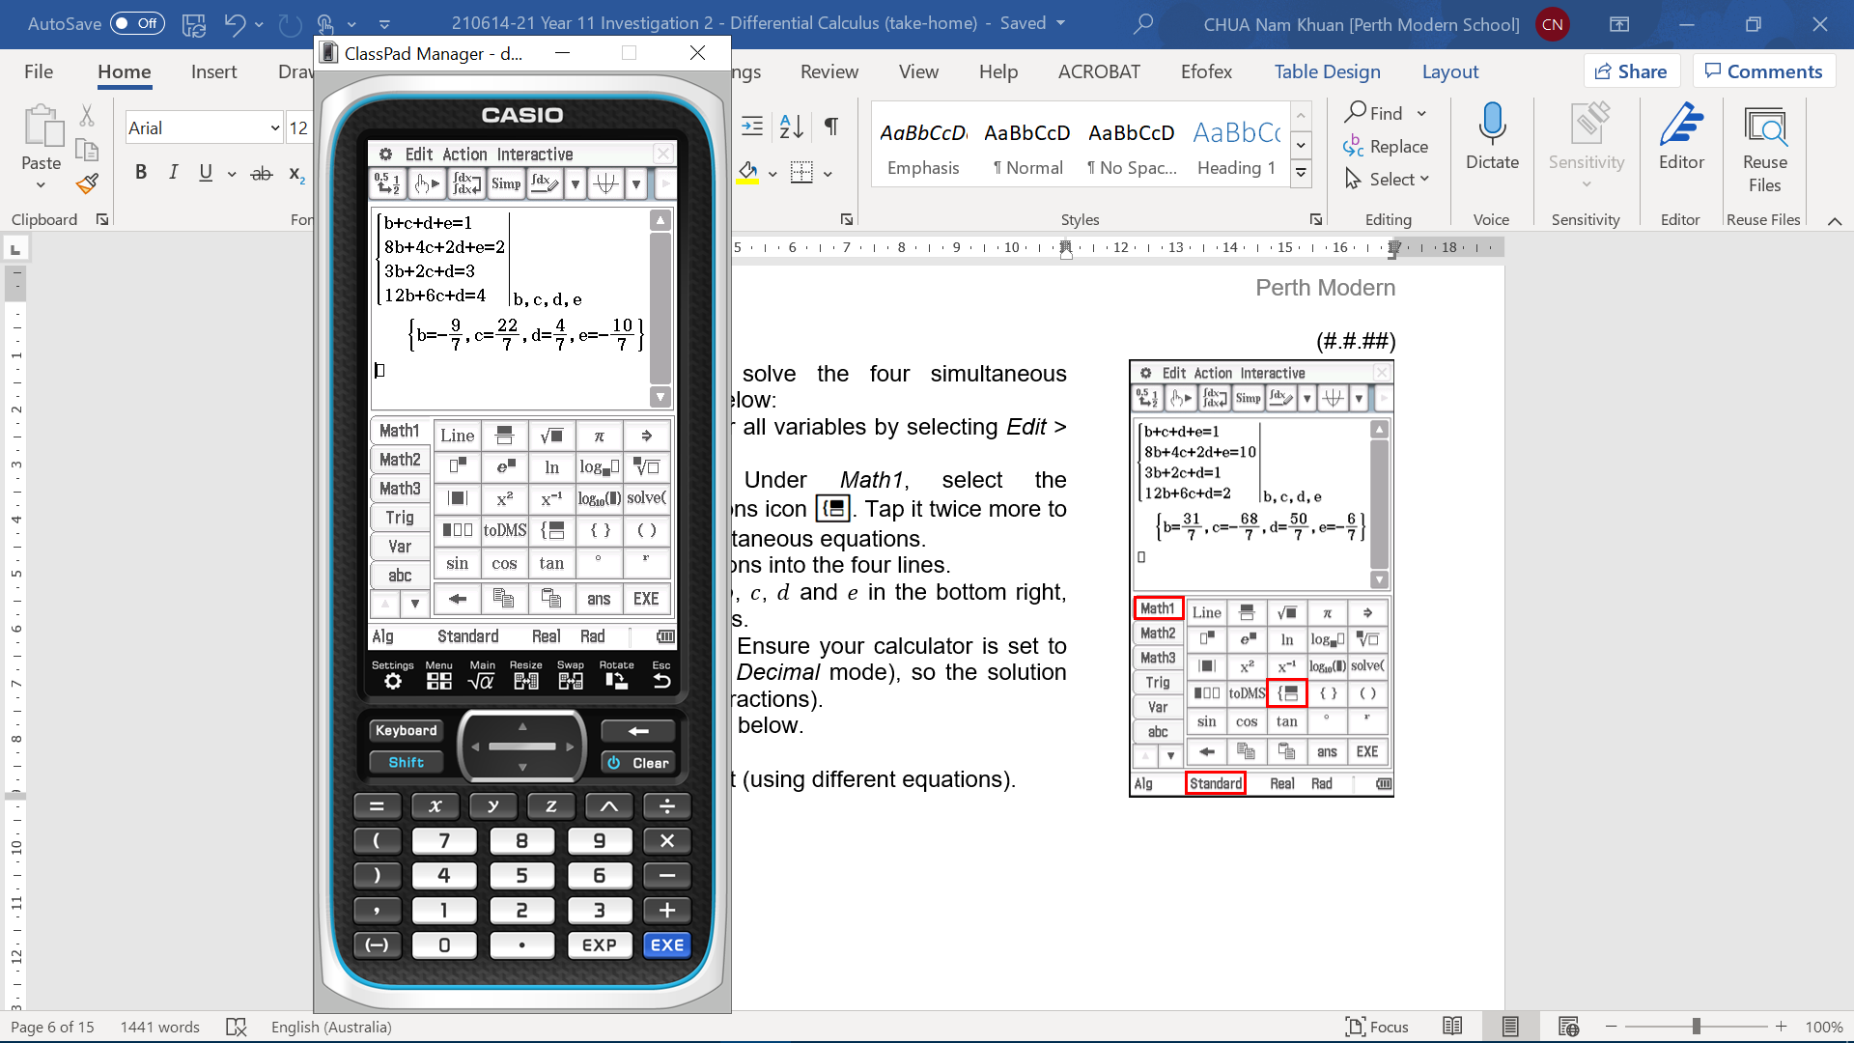

Hence, state the fully defined equations for the velocity and acceleration.

Hence, plot the velocity and acceleration profiles in the graphs below.
Use your ClassPad to check the shape of the graphs.
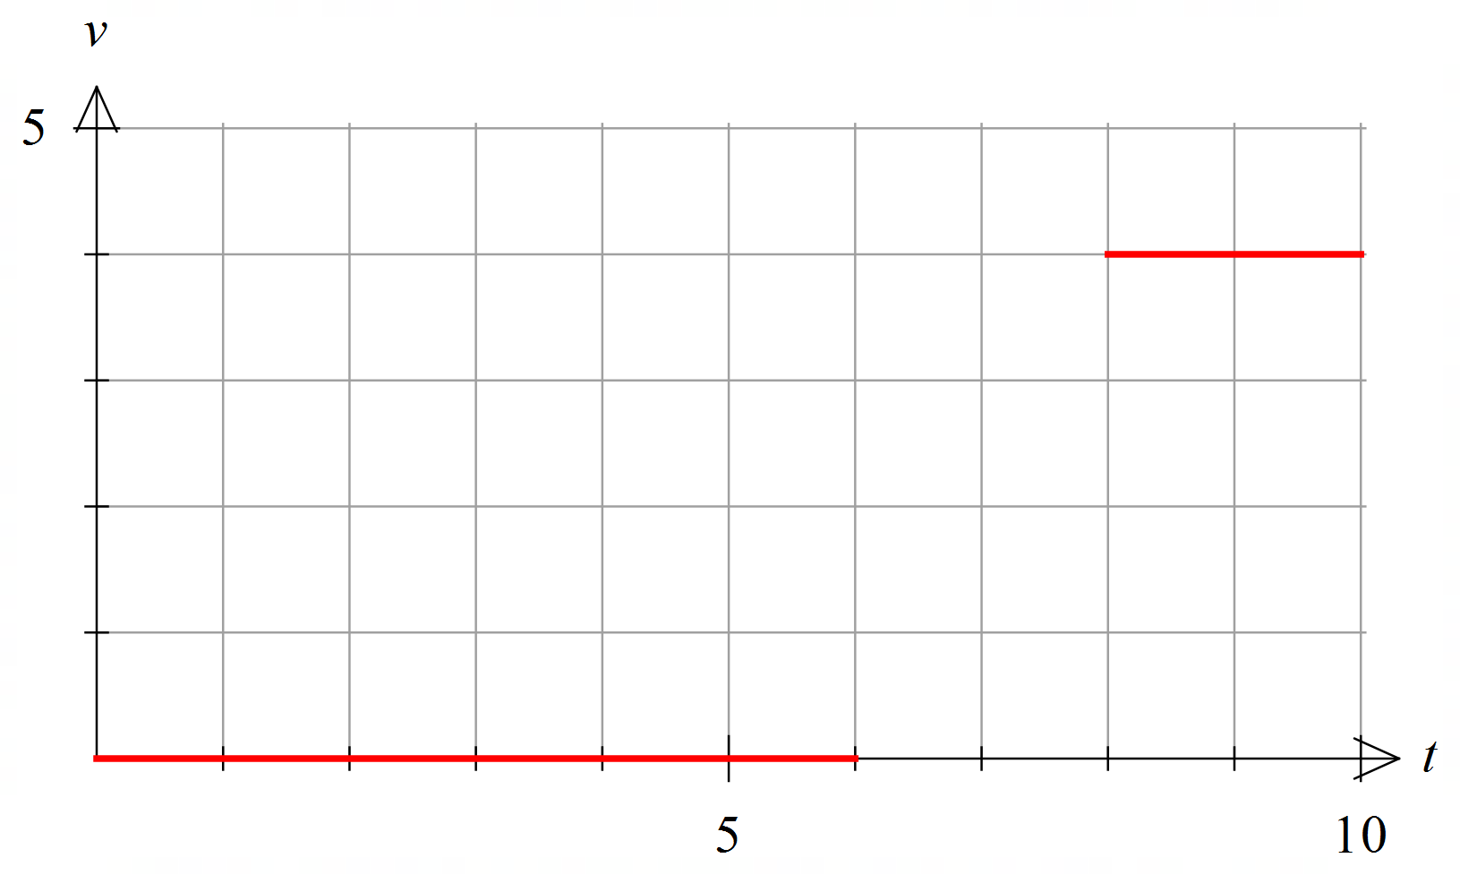

Using differential calculus, determine the piecewise function of the elevator’s jerk $j m/s^{3}$.

Hence, plot the jerk profile in the graph below.
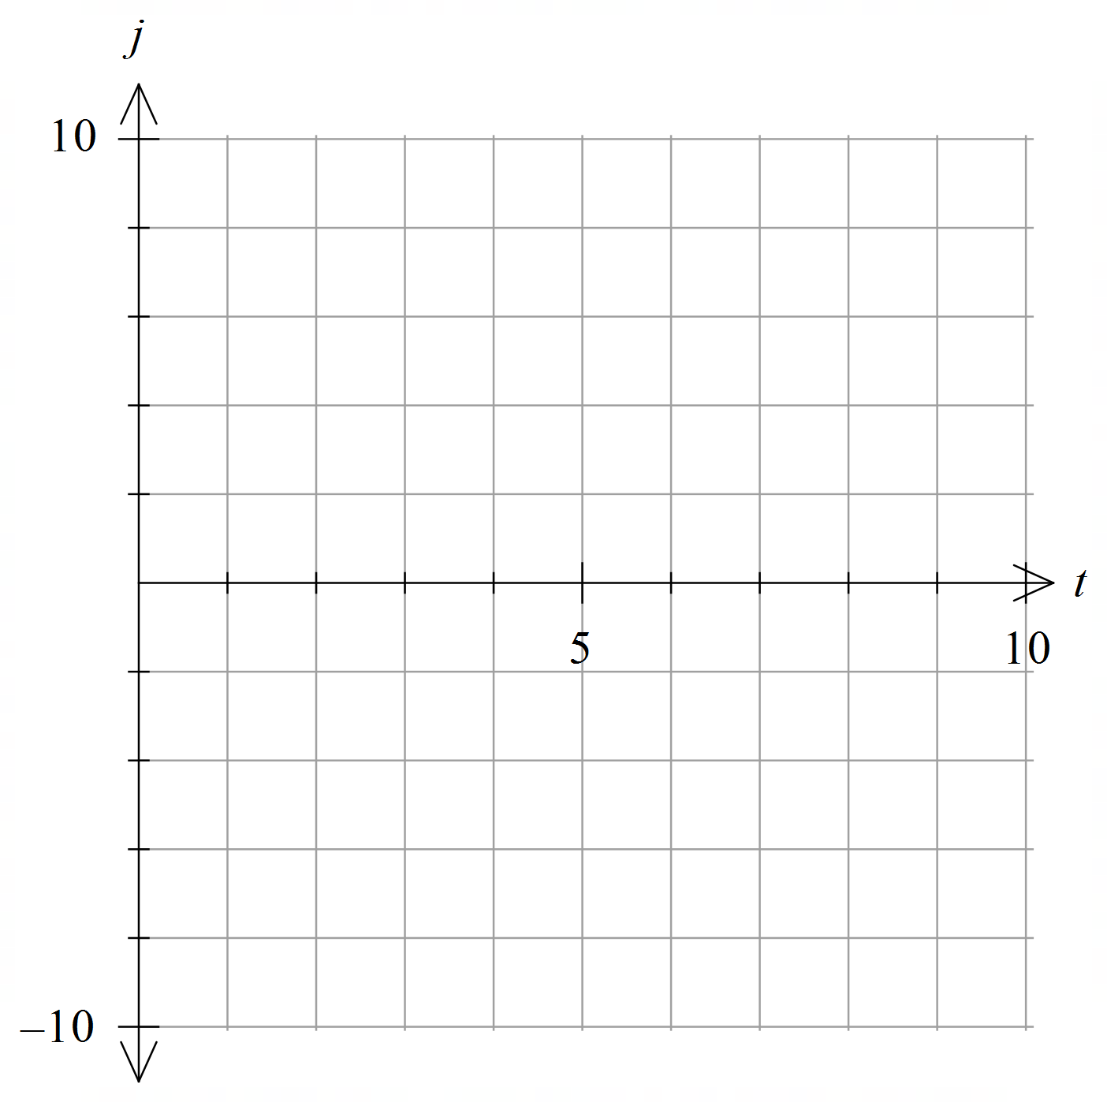

What is the maximum acceleration and jerk?

You may have noticed that the maximum acceleration has increased to $3 m/s^{2}$, while the maximum jerk is now a quantifiable $6 m/s^{3}$. Ramping the acceleration to reduce jerk takes longer than instantaneously applying it, so with a fixed acceleration time, a higher peak acceleration is required to reach the same final velocity.

Suppose the limits for acceleration and jerk are $1.5 m/s^{2}$ and $2 m/s^{3}$ respectively. If the elevator is initially stationary and still needs to reach $4 m/s$ by $t=8 s$ (as shown right) using a cubic velocity profile, predict the latest time that the elevator needs to start accelerating to meet the acceleration limit.  What do you think the maximum jerk will be? | 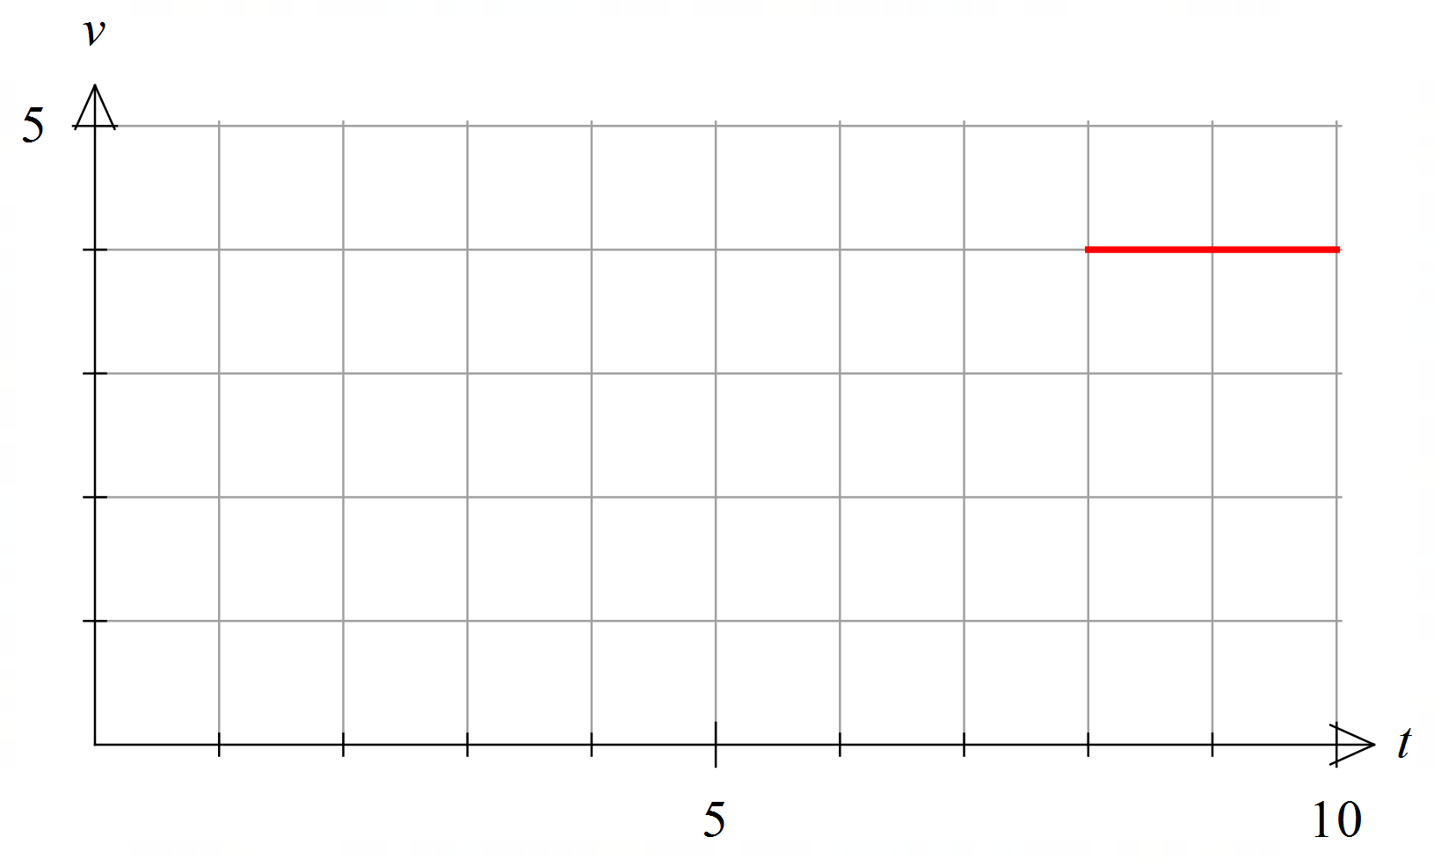
Verify your predictions by analysing the motion as previously.

State the generalised piecewise functions of the elevator’s velocity and acceleration.

State the points that the velocity and acceleration functions need to pass through, then use them to develop four simultaneous equations.

Using your ClassPad, solve the four simultaneous equations.

Hence, state the fully defined equations for the velocity and acceleration.

Plot the velocity and acceleration profiles in the graphs below.


Determine the piecewise function of the elevator’s jerk and plot it in the graph below.
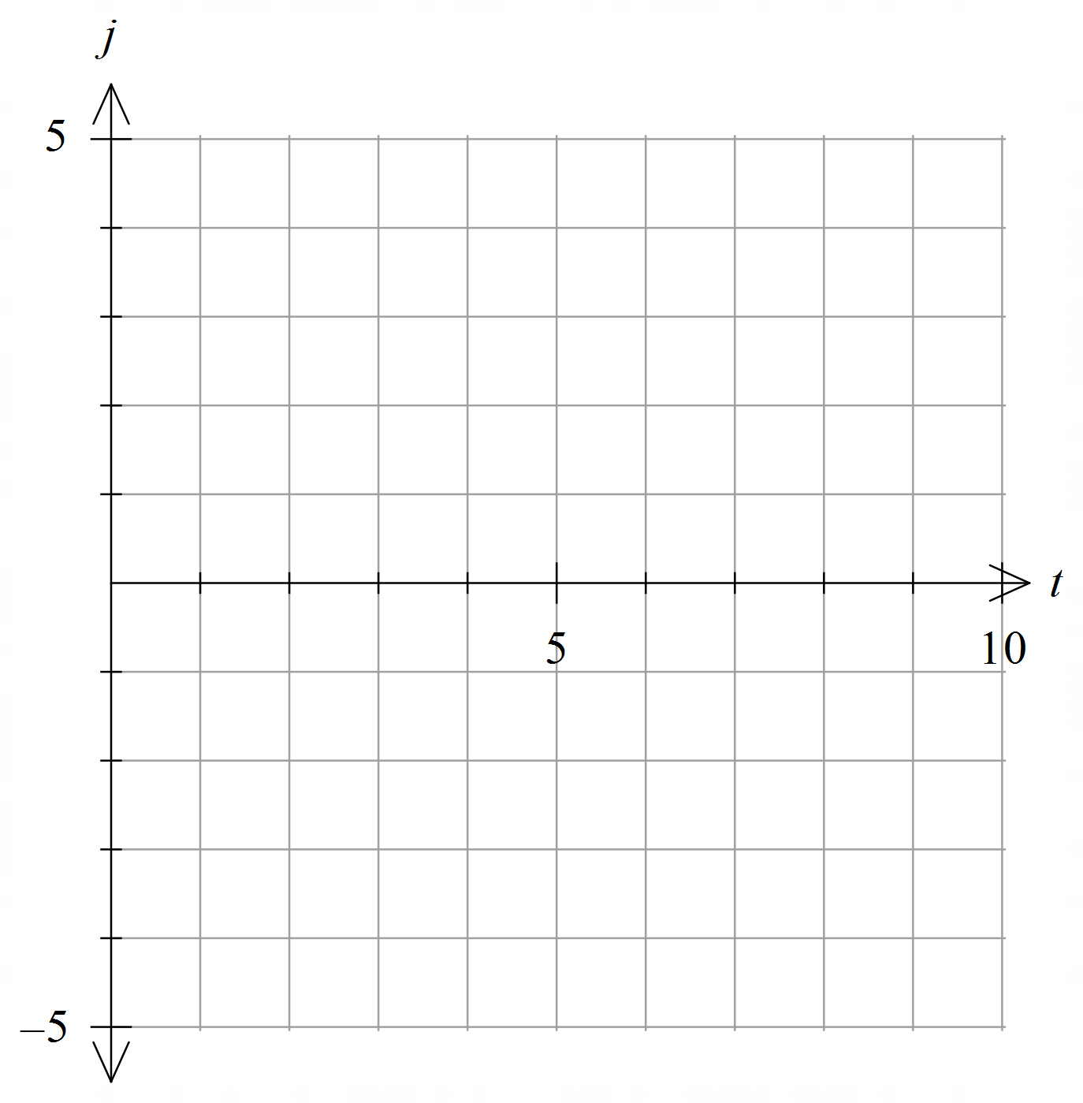

What is the maximum acceleration and jerk? Does this meet your prediction and the limits?

